Happenings At New Hope

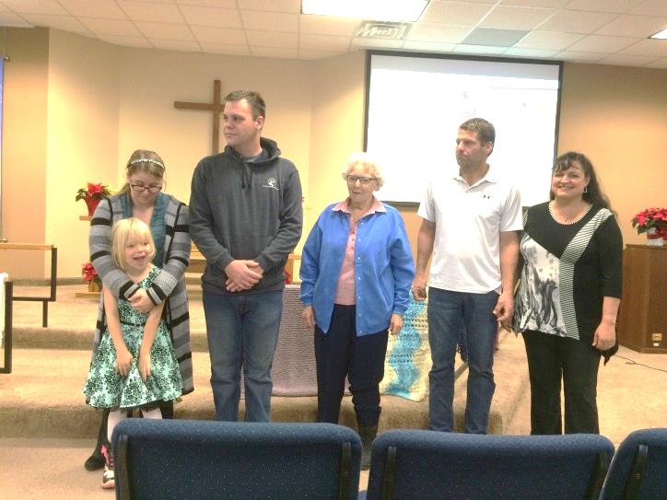
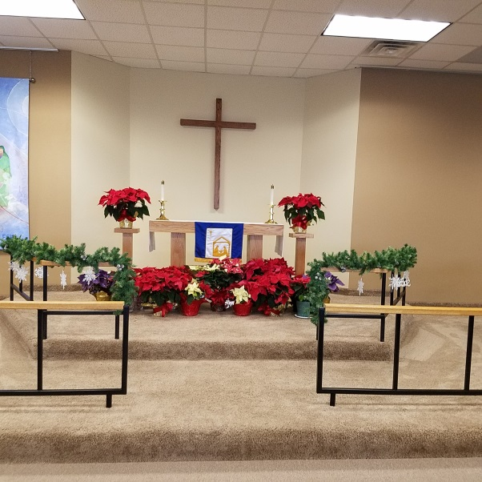
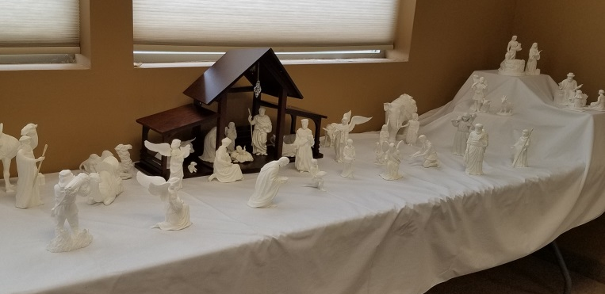
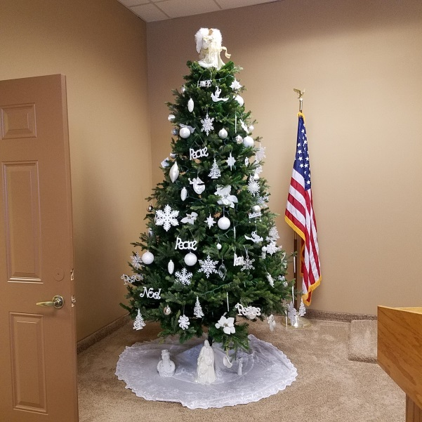
Thank you to our members for the time and energy you gave to make this Christmas season so beautiful and meaningful for all. Thank you to those who decorated the front of our church and set up the outdoor manger scene. Thank you for the wonderful Christmas display in the park and the message it delivered. Thank you to those who set up and decorated our Christmas tree, and took charge of our Advent Wreath and Christmas Eve candles. Thank you to those who set up the beautiful Christmas banners in the front of the sanctuary, set the Communion table and beautified the Altar area with Christmas flowers and set up the wonderful Nativity Scene in the back of our church. Thank you to our ushers and those who worked our sound system and video projection. Thank you to all who made the Christmas cookies and gave plates of cookies to so many families and sent several to those serving in the military. Thank you to those who supported and put together the shoeboxes of gifts for Operation Christmas Child. Thank you to those who had charge of our Fellowship time after church. Thank you to our young people and their teachers for the meaningful Christmas program. Thank you to our choirs, choir director and pianist, and those individuals who blessed us with their special music. And thank you to all our members and friends for being a part of our ministry here. We have a wonderful and blessed congregation. Thank You.
December 4 we welcomed six new members to New Hope. Mike and Marilyn Toraason, Shirley Mariette, Paul, Casey and Michaela Corty.

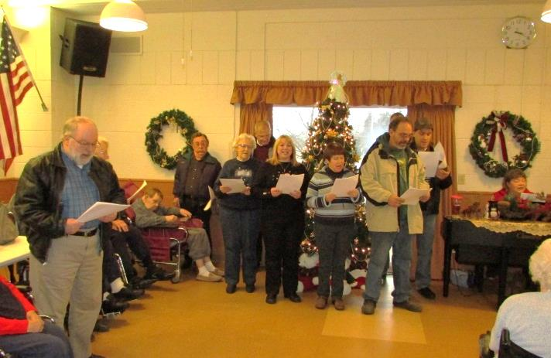
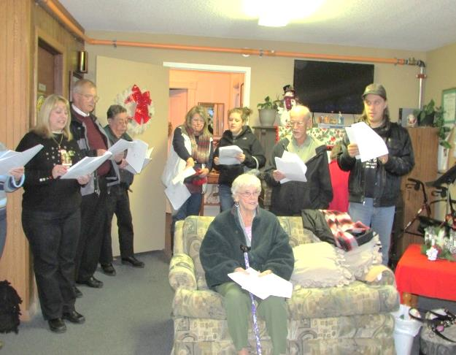
December 10 Christmas Caroling, Members and friends of New Hope went to the local Nursing homes to share some Christmas Carols with the residents.

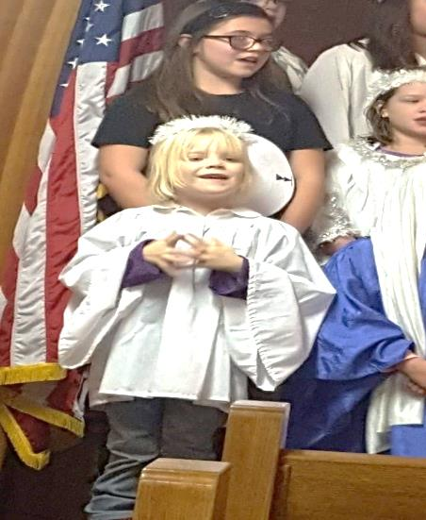
December 11 we were blessed with a joint Christmas Program that took place out at Calvary Covenant Church. The Sunday School Children from both churches as well as those who attend the Wednesday after school progam of Noah’s Park came together to put on the heartwarming performance.

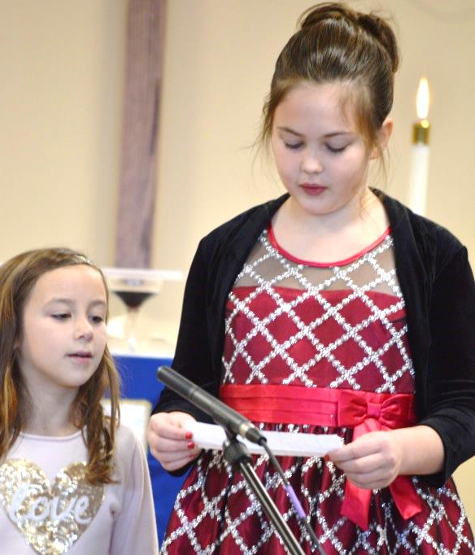
(Pictured to the left and below)
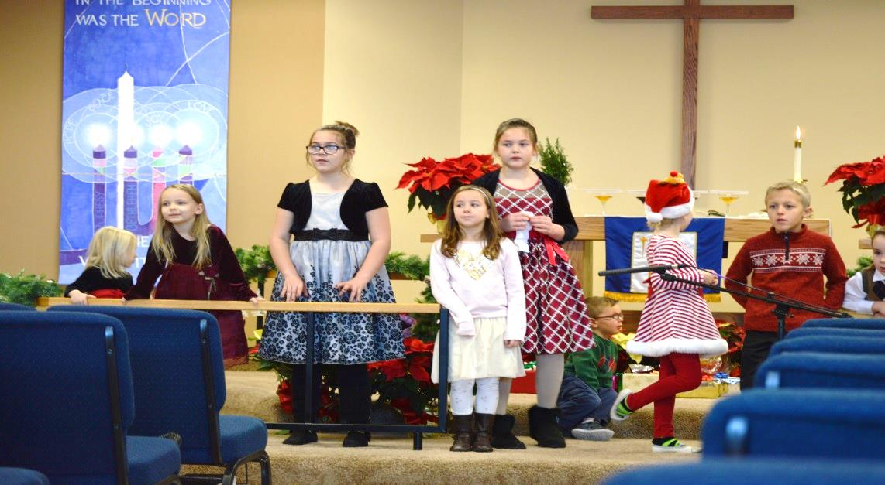
Decemeber 18 The New Hope Sunday School presented their Christmas Program to our Congregation. The Program was entitled “ What Gift shall you bring“ Participants in the program included Axel, Archer, and Abe Hale, Dane and Kaylie Moore, Piper and Presley Olson, Michaela Corty, Conner and Tanner Hanson,Madeline and Kaylee Grass.

,
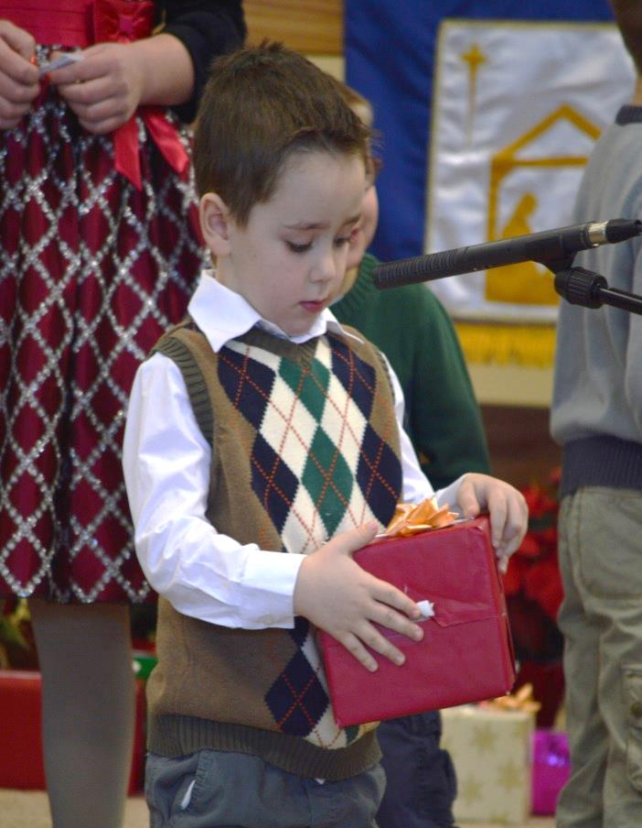

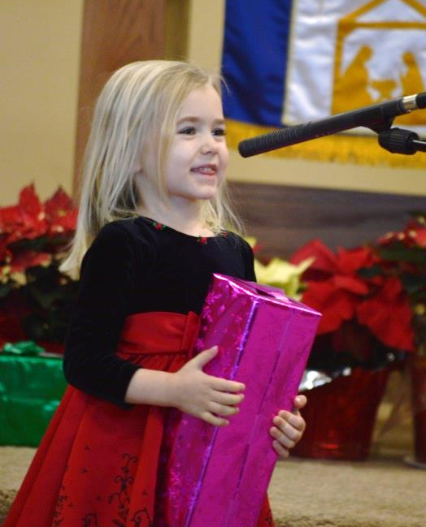
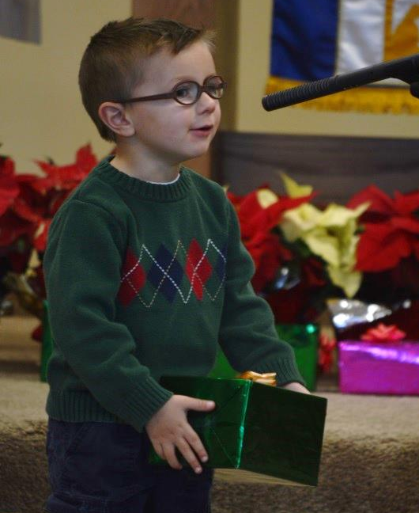

January 2017
1 | 2 | 3 | 4 | 5 | 6 | 7
New Year’s Day  Regular Worship Service |  |  | Men’s Bible Study:  6:30 am  Quilting 9am  Prayer meeting: 2 pm  Noah’s Park 3:30 (Calvary)  Choir:7:00 pm |  | Visitation for Lawrence “Larry” Pederson  4 PM at Rowe Funeral Home in Frederic | Memorial Services  for  Lawrence “Larry” Pederson  11 am with a luncheon to follow  Here at New Hope
8 | 9 | 10 | 11 | 12 | 13 | 14
Eunice Tollander 90th Birthday Celebration during Fellowship |  |  | Men’s Bible Study:  6:30 am  Quilting 9am  Prayer meeting: 2 pm  Noah’s Park 3:30 (Calvary)  Choir:7:00 pm | Board of Worship Meeting:  6:30 pm  Board of Trustees Meeting:  6:30 pm  Full Council Meeting:  7:30 pm
15 | 16 | 17 | 18 | 19 | 20 | 21
All Committee Reports Due!  CCC/Shady Knoll Worship Service |  |  | Men’s Bible Study:  6:30 am  Quilting 9am  Prayer meeting: 2 pm  Noah’s Park 3:30 (Calvary)  Choir:7:00 pm
22 | 23 | 24 | 25 | 26 | 27 | 28
Annual Report Packets will be in your boxes if you don’t receive one please see Casey | Divorce care  Small Group Leaders meeting 6pm |  | Men’s Bible Study:  6:30 am  Quilting 9am  Prayer meeting: 2 pm  Choir:7:00 pm
29 | 30 | 31 | 1 | 2 | 3 | 4
Men’s Bible Study:
6:30 am
Quilting 9am
Prayer meeting: 2 pm
Noah’s Park 3:30 (Calvary)
Choir:7:00 pm
5 | 6 | 7 | 8 | 9 | 10 | 11
Annual  Meeting | 1st session of Divorcecare  6 pm |  | Men’s Bible Study:  6:30 am  Quilting 9am  Prayer meeting: 2 pm  Noah’s Park 3:30 (Calvary)  Choir:7:00 pm

NEW HOPE LUTHERAN CHURCH
685 W. State Rd. 70
P. O. Box 7 Grantsburg, WI 54840 Dr. Emory L. Johnson, Pastor
Church Office: 715-463-5700
Fax: 715-463-5770
Secretary Email: info@newhopelutheranchurch.org
Website: newhopelutheranchurch.org
https://www.facebook.com/grantsburgnewhopelutheranchurch/

NEW HOPE LUTHERAN CHURCH UPDATE
January 2017

To the New Hope Lutheran Congregation:

- Sunday January 8. Eunice Tollander’s Family will be celebrating her 90th birthday with our congregation during fellowship time.
NOTICE OF ANNUAL MEETING
- PLEASE TAKE NOTICE, MEMBERS OF NEW HOPE LUTHERAN CHURCH: The Annual Meeting of New Hope Lutheran Church will take place on Sunday, February 5, 2016, immediately following the worship service.

- Visitation for Lawrence “Larry” Pederson will be Friday, January 6 from 4-7 pm at Rowe Funeral Home in Frederic. There will be a Memorial Service here at New Hope on Saturday, January 7 at 11 am with visitation being one hour prior and a luncheon to follow the service. Please contact the church office at 715-463-5700 if you can help with the luncheon. We are in need of open faced sandwiches or bars and volunteers to help with set-up, serving or clean-up.

- All Committee Reports are Due ~Please turn in your reports to Casey in the church office by the January 15 deadline. The 2016 Annual Report is scheduled to be distributed to the congregation January 22 and it can only be completed with all the committee reports. Thank you.

- The Multicongregational Bake sale that was held December 3rd raised $1700 dollars toward the Grantsburg Backpack Program. This program is such a blessing to so many families in our community. Thank you to everyone who provided baked goods, helped with the serving table as well as setting up and cleaning up, and thank you to those who gave to the free will offering.

- December 4 our congregation sent Christmas cards and cookies to those military members that we have on our prayer list. Thank you to all who helped make this possible. These cookies were a blessing to a dozen military members.

- THANK YOU - A very heartfelt thank you to all the volunteers who helped to make the “Cookies for our Congregation” a great success. Thank you to those who donated baked goods and other treats, to those who donated funds, and to those who helped set up and clean up afterwards. $490.21 was given toward Nicole Dalsveen’s band trip to Florida this coming summer.
Thank you all and God Bless.

- Thank you from Pastor Emory~ Pastor Emory and Meta would like to thank the Congregation and Council of New Hope Lutheran Church for all the wonderful cards, thoughts and gifts that you gave to us this Christmas. The messages on the cards were so meaningful and you blessed us. Thank you.

- DivorceCare is coming to New Hope in the New Year; sessions will begin Feb 6 at 6pm. DivorceCare is a support group for individuals that are experiencing a divorce or separation. This is a 13-week video driven program produced by top experts in grief and recovery fields. The small groups are led by those who have experienced and moved through this difficult life experience and are able to help restore hope in this Christ-centered ministry. If you are interested in this ministry please call or email the church office. There will be a meeting for the small group leaders Jan 23 at 6pm.

- Quilting is starting again. Come join us on Wednesdays, at 9 am for fellowship and quilting. Everyone is welcome--sewing is NOT required to help!

- At each of our Sunday services there are opportunities to help assist in our time of worship. If you are willing and able to volunteer for any of the ministries needed please check out the sign-up sheet on the bulletin board in the fellowship hall. We have various areas in which we need help from the congregation. Also, if there is a time you would like to bring altar flowers in honor or memory of someone, or just because, there is a sign-up sheet for that too. Thank you to all who volunteer their time and talent at New Hope!
.
- Men’s Bible Study- Book of Acts~ An interesting study, filled with action and adventure so relevant to finding peace and direction in our turbulent times is being led by Dr. Ken Hyatt, on the Book of Acts. This study is offered Wednesday mornings at 6:30 am at the “Grantsburg Mo Joe” formerly known as the Wake-Up Call Coffee House.

- Bible Study Psalm 91 Do thoughts on terrorist attacks and epidemic outbreaks cause your heart to skip a beat? What about all the natural disasters that are striking in unexpected places? Do you sometimes wonder if there is any safe place in the world to hide? If any of these things has ever troubled your mind, please join us for an in-depth study of Peggy Joyce Ruth's Bible Study titled "Psalm 91 God's Umbrella of Protection" This study meets at Tammy and Gene Blomberg's home 13350 North Rd., Grantsburg, on the second and fourth Sunday's at 7:00 pm

- Facebook` You can now find New Hope on Facebook. Please click on “Like” and “Share”.
https://www.facebook.com/grantsburgnewhopelutheranchurch/.

- The next Council meeting is Thursday, January 12 at 7:30pm. Anyone is welcome to attend or bring issues to a Council member to be addressed.

Our church family is filled with many talented and generous people! I’d like to thank everyone for volunteering their time and expertise in various areas, both large and small. We have had an exciting year and are growing. The Ministry accomplished here could not be done without the generosity of everyone involved. God has truly blessed us at New Hope.

Casey Corty
NHLC Secretary

Thy word is a lamp unto my feet and a light unto my path.
Psalm 119:105

