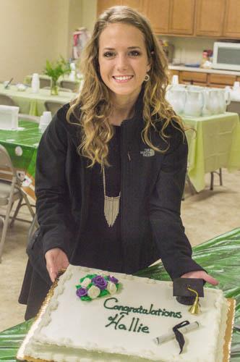
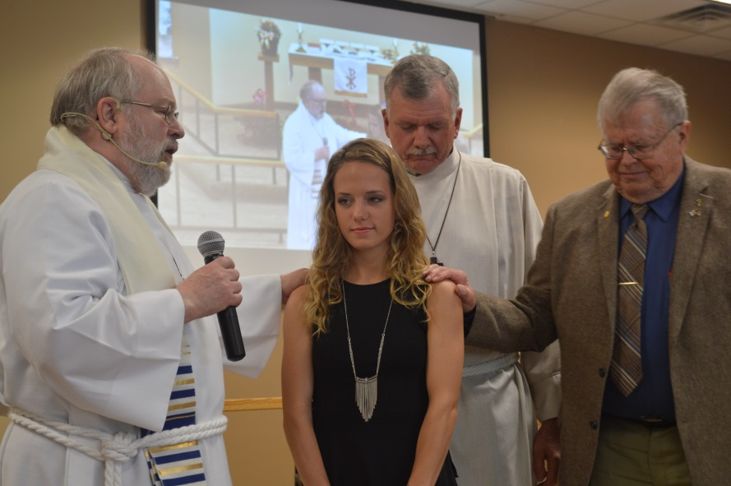
Congratulations to our 2017 graduate and Valedictorian
Hallie Jensen. May God’s richest blessings be with you as you enter this next chapter of your life!

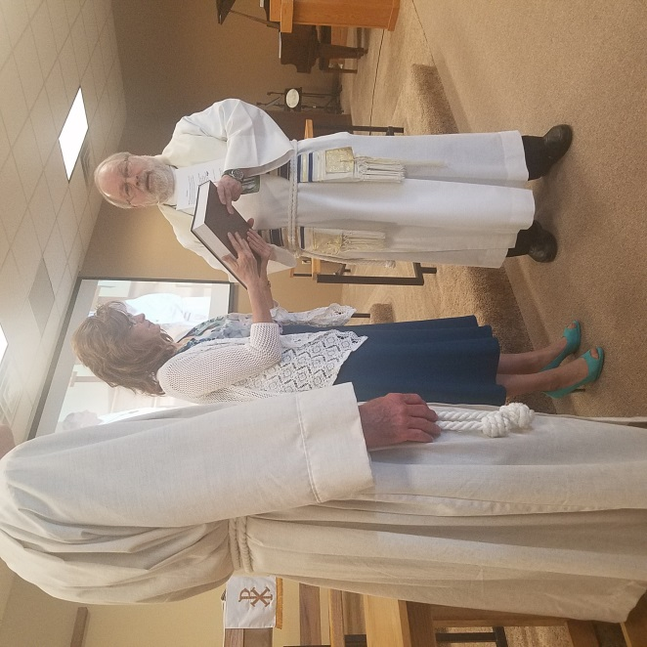
Thank you to Melissa McIntyre for serving as Parish Assistant for our Women's Ministry, Congregational Prayer and Bible Study. Our prayers are with you as you move on in God's Calling for your life. God Bless You.

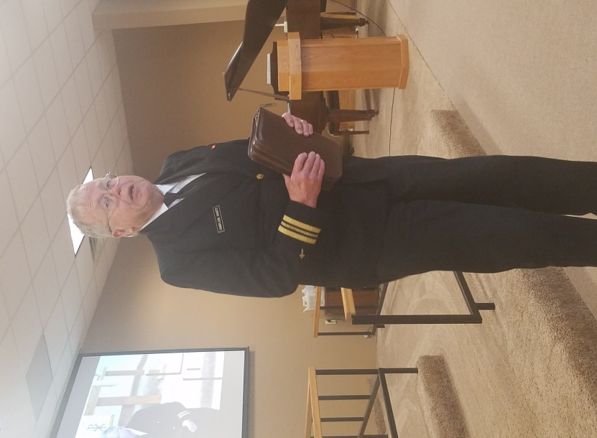
Memorial Day May 28

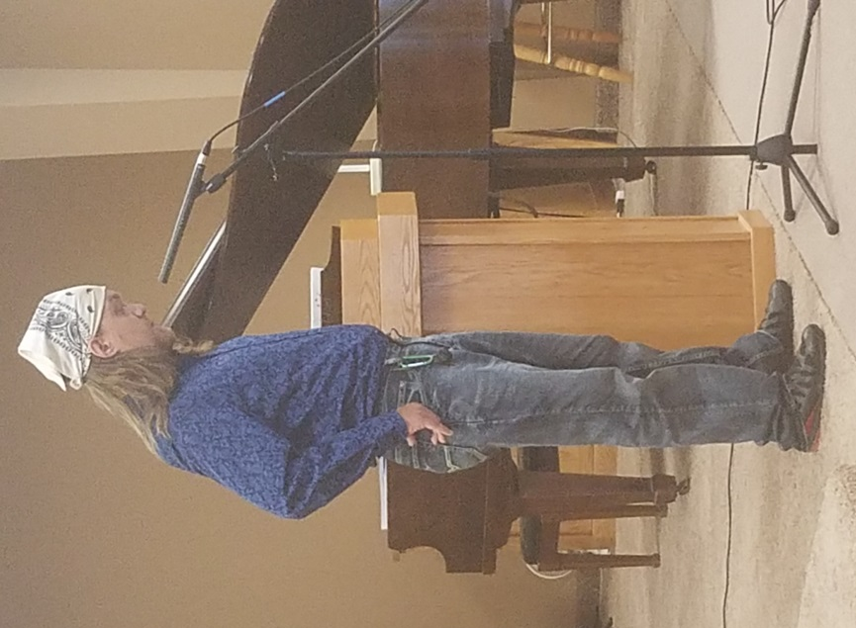

Memorial Day Remembrance presented by Chaplain Ken Hyatt
Thank You to Mike Corty for your special Memorial Day music for us.

June 2017
28 | 29 | 30 | 31 | 1 | 2 | 3
4 | 5 | 6 | 7 | 8 | 9 | 10
Worship Service:9:30 am  Followed by  coffee and fellowship  Adult Bible Study :  11:15-11:45 am |  |  | Men’s Bible Study:6:30 am  Quilting 9am  Prayer meeting: 2 pm | Council Meetings beginning  at 6:30 pm
11 | 12 | 13 | 14 | 15 | 16 | 17
Worship Service:9:30 am  Followed by  coffee and fellowship  First Communion Class  Congregational Meeting  Worship at  CCC & Shady Knoll 1:50 pm |  |  | Men’s Bible Study:6:30 am  Quilting 9am  Prayer meeting: 2 pm
18 | 19 | 20 | 21 | 22 | 23 | 24
Father's Day  Worship Service:9:30 am  Confirmation Class  10 :45am  Followed by  coffee and fellowship  Adult Bible Study :  11:15-11:45 am | DivorceCare  6-8 pm |  | Men’s Bible Study:6:30 am  Quilting 9am  Prayer meeting: 2 pm
25 | 26 | 27 | 28 | 29 | 30 | 1
Worship Service:9:30 am  First Communion Class 10:45 am  Followed by  coffee and fellowship  Adult Bible Study :  11:15-11:45 am | DivorceCare  6-8 pm  Vacation Bible School at Calvary Covenant  1:30-5 pm | Vacation Bible School  at  Calvary Covenant  1:30-5 pm | Men’s Bible Study:6:30 am  Quilting 9am  Prayer meeting: 2 pm  Vacation Bible School  at Calvary Covenant  1:30-5 pm | Vacation Bible School at  Calvary Covenant  1:30-5 pm | Vacation Bible School at  Calvary Covenant  1:30-5 pm

NEW HOPE LUTHERAN CHURCH
685 W. State Rd. 70
P. O. Box 7 Grantsburg, WI 54840 Dr. Emory L. Johnson, Pastor
Church Office: 715-463-5700
Fax: 715-463-5770
Secretary Email: info@newhopelutheranchurch.org
Website: newhopelutheranchurch.org
https://www.facebook.com/grantsburgnewhopelutheranchurch/

NEW HOPE LUTHERAN CHURCH UPDATE
June 2017

To the New Hope Lutheran Congregation:
- Thank you~ Thank you to all the MANY volunteers and attendees who helped makes the Progressive Dinner a wonderful success! Preliminary totals for donations from all the proceeds from this event appear to be in excess of $3,000. Our area churches are now about half-way to the annual goal of $12,000 for the Grantsburg Lunch Backpack program. The Salvation Army wishes to also express their deep thanks. Our help in supporting this program does indeed feed children in need, and it also releases their Red Kettle funds to other social programs for people in need. We are being a positive impact in this community and showing the Love of Christ. THANK YOU to each of you for your contribution of time, talent, energy and participation.

- Thank you~ Thank you to everyone who helped make Bible Baseball such a big success. Thank you to everyone who participated in the game, those who helped prepare the food, those who helped with decorating, set up, and those who helped with clean up. You are most appreciated

- Thank you~ Thank you very much to our congregation for your donations to the yard sale benefitting the Grantsburg Backpack Program. Thanks to the shoppers who came and shopped. With all of the nice things that were given to us the yard sale was a great success providing us the necessary funds for this program. There are no words to truly express our gratitude to all the dedicated volunteers who worked at the sale, hauled and sorted the rummage items and helped to set up and clean-up. We thank you greatly for your kindness.

- Worship at CCC & Shady Knoll ~ Next Sunday June 11. New Hope will be providing the Worship Services at CCC and Shady Knoll. Everyone is welcome to join us as we sing hymns and minister to the residents. Meet at CCC at 1:50 pm.

- Vacation Bible School ~
Calvary Covenant and New Hope’s VBS for ages 4 years old through 6th grade, is set for the week of, June 26-30. The theme for this year is Kickin’ it Old School. If you are interested in volunteering to help please see Casey. If you are interested in your child attending please fill out a registration form located on the back table of the sanctuary.

- DivorceCare~
A new session of DivorceCare is beginning this month. This 14 week series will be held Mondays starting June 19 from 6:00 to 8:00 pm. DivorceCare is a weekly video seminar series and support group for people who are separated or divorced. This 14-week program is produced by top experts in grief and recovery. Videos are combined with support group discussions of the materials presented each evening and covers the topics of facing anger, depression and loneliness, new relationships, financial survival, forgiveness, reconciliation and moving on. The small groups are led by those who have experienced and moved through this difficult life experience and are able to help restore hope in this Christ-centered ministry. If you are interested in attending the sessions or would like more information please call Kobi Phillipps at (715) 431-0187 or email the church office:info@newhopelutheranchurch.org. Pre-registration is appreciated but walk-ins are welcome

- June 11 Congregational Meeting~ There will be a short congregational meeting after the Worship Service June 11 authorizing the purchase of a parcel of land located along highway 70 adjacent to the Grantsburg Schools. If you would like an information packet about the land prior to the meeting please see Casey.
- Bible Camp Scholarship~New Hope is offering scholarships to those youth who wish to attend a Bible Camp this summer. Just call the Church Office and let Casey know where and when you wish to go to camp.

- Tuesday Bible Studies~ This Study group is meeting on Tuesdays at 7 pm (in the Sunday School room).

- Prayer Shawls ~ If you know someone who could use a prayer shawl, please contact Sylvia Hanson. Those of you who are making prayer shawls can put them in the totes in the storage room. God bless all of you for making these prayer shawls. They give much hope and love to each receiver.

- Men’s Bible Study- Book of Hebrews~ An interesting study, filled with action and adventure so relevant to finding peace and direction in our turbulent times, led by Dr. Ken Hyatt, is being presented on the book of Hebrews. This study is offered Wednesday mornings at 6:30 am at the “Grantsburg Mo Joe” formerly known as the Wake-Up Call Coffee House

- Bible Study Galatians Please join us for an in depth study of the book of Galatians. Paul's letter to the Galatians was addressed to a group of churches in Galatia a region of modern day Turkey. Have you ever wondered: Why is Galatians so important? Why does Paul seem so angry with these churches? What is the big idea of this book? How do I apply this in my life? Please join us as we study to find answers to these questions and more. This study meets at Tammy and Gene Blomberg's home, 13350 North Rd., Grantsburg, on the second and fourth Sunday's at 7:00 pm

- Quilting is starting again. Come join us on Wednesdays, at 9 am for fellowship and quilting. Everyone is welcome--sewing is NOT required to help!

- The next Council meeting is Thursday, July 13 at 7:30pm. Anyone is welcome to attend or bring issues to a Council member to be addressed.

Our church family is filled with many talented and generous people! I’d like to thank everyone for volunteering their time and expertise in various areas, both large and small. We have had an exciting year and are growing. The Ministry accomplished here could not be done without the generosity of everyone involved. God has truly blessed us at New Hope.

Casey Corty
NHLC Secretary

Thy word is a lamp unto my feet and a light unto my path.
Psalm 119:105

