April 8th Easter for Kids was held here at New Hope. The children spent the morning playing, games, doing crafts, and having lessons about the death and resurrection of Jesus. Something new that was added this year was each child received a keepsake T-shirt (pictured) to take home.
“I would like to say a big thank you to all who helped with Easter for Kids this year! We had 27 children attend and it was a wonderful morning. All of you volunteers are such a blessing and I appreciate each and every one of you. God bless you! -Sara”

Our April 9th Palm Sunday Service began with the children of the church marching down the aisle waving their palm branches. The Service continued on with the choir retracing Christ's final days and journey to the cross through a Contemporary Tenebrae Service. “Hope in the Shadows” recalled Christ’s journey to the cross by examining the shadows of betrayal, injustice, & agony that marked that journey.

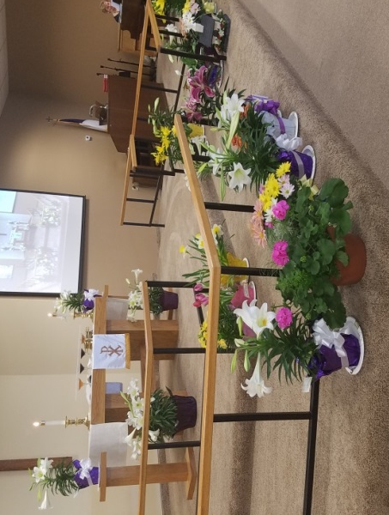
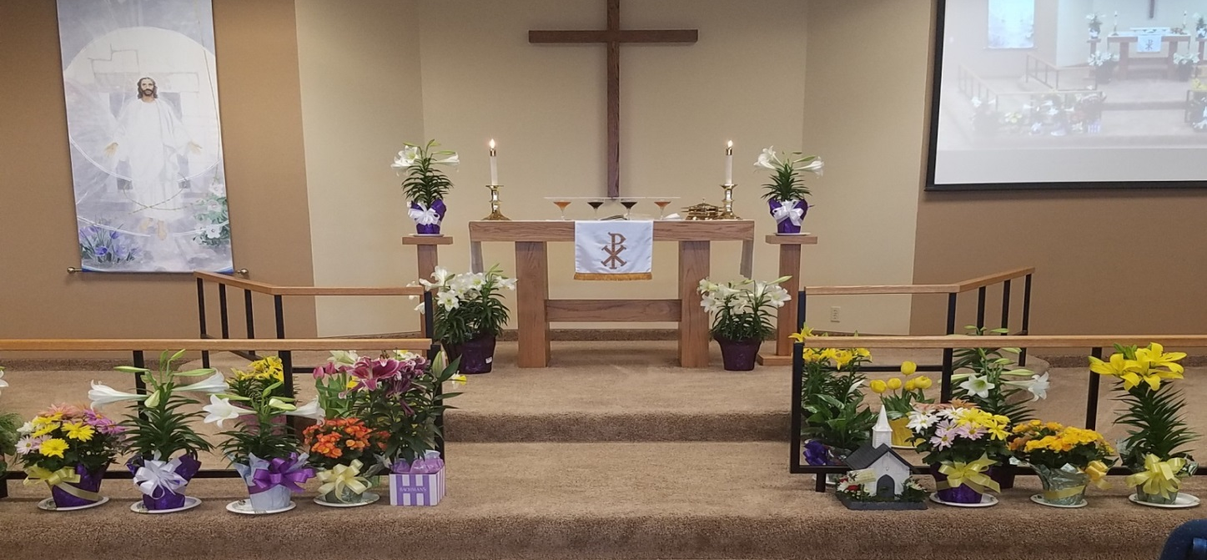

Thank you to everyone who brought in a plant in honor, memory or appreciation of someone for the
2017 Easter garden

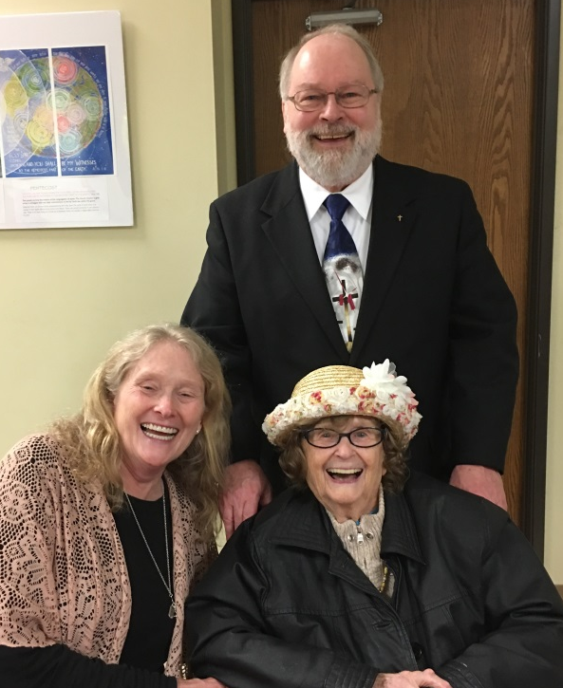
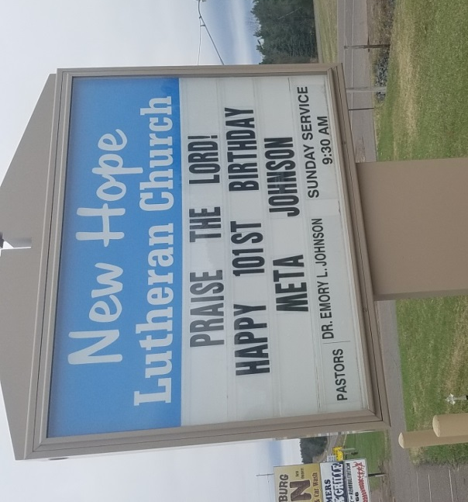
April 23rd Meta Johnson, mother of Pastor Emory Johnson, celebrated her 101st Birthday during a Congregational Fellowship Luncheon after the Worship Service at New Hope on Sunday, April 23. Pastor Emory and his sister, Naila Sanderson of New Richmond, had the Kozy Kitchen cater their famous chicken, with Au Gratin potatoes and coleslaw. The New Hope Lutheran Church women provided salads, fruit, vegetables, desserts, and decorated the Fellowship Hall with colored table clothes, flowers and balloons, for a festive birthday celebration. Over 150 members, friends and relatives joined with Meta to celebrate her birthday.
Pictured in front from left to right are Naila Sanderson and Meta Johnson with Pastor Emory standing behind them.

Pastor Emory and Meta would like to thank the congregation for all the cards, gifts, and birthday greetings that were given. They would also like to thank the New Hope women who worked so lovingly to decorate the Fellowship Hall with colored table cloths, balloons, flowers and the beautiful large birthday card for everyone to sign. And thank you for all the delicious salads, fruit, vegetables and desserts. This was a very special day and you blessed us.
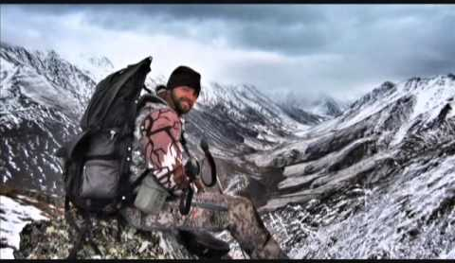

April 26. Thank you to everyone who came out to hear our special guest speaker Alaskan Guide, Billy Molls. Everyone was entertained by his one-of-a-kind portrayals of North America’s Last Frontier and sat spellbound on the edge of their seats as he told stories of adventure, excitement and inspiration from the untamed wilderness of Alaska! His message about how he came to have a personal relationship with Jesus Christ while in the wilderness was inspiring.
Pictured: Billy Molls, Alaskan Game Guide.

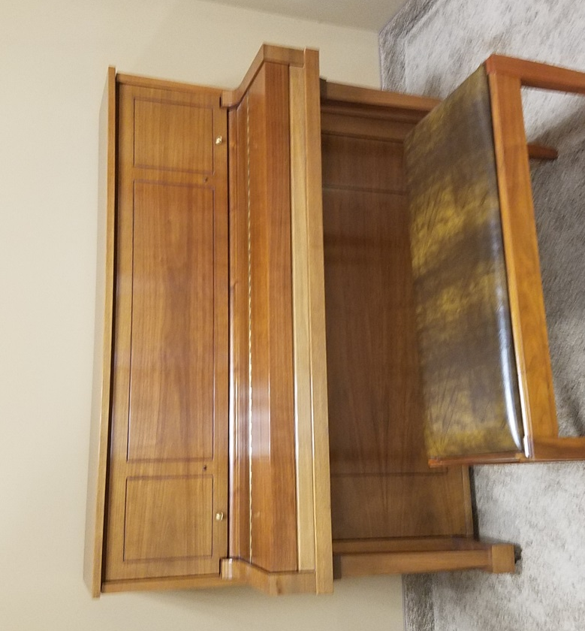
The generous gift of a beautiful Steinway console piano was donated to our church. This is one of the finest and best sounding console pianos made. The blessing of this gift is greatly appreciated.

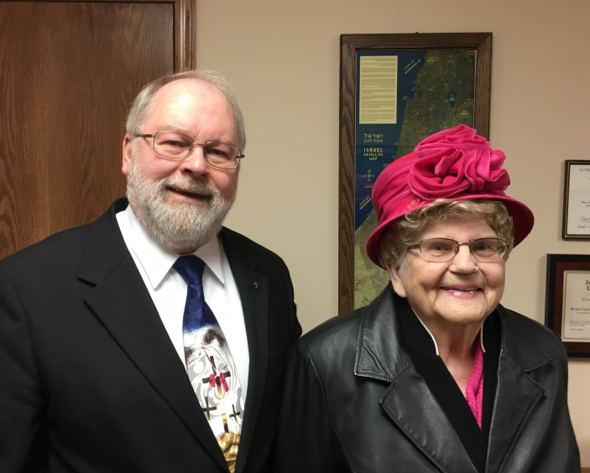
April 30, Thank You to Pnina Ben Yaakov of Shalom Music International in Jerusalem, Israel for her ministry with us this past Sunday. A music ministry C.D. of Shalom Music's 31st album, He is Coming Again, was given to everyone and is available in the church office to anyone who would like one.

Pictured left to right: Pastor Emory and Pnina Ben Yaakov of Shalom Music International

May 2017
30 | 1 | 2 | 3 | 4 | 5 | 6
 | DivorceCare  6-8 pm | Gospel of John  Bible Study  7 pm | Men’s Bible Study:6:30 am  Quilting 9am  Gospel of John  Bible Study: 12 pm  Prayer meeting: 2 pm  Noah’s Park 3:30 (Calvary)  Choir:7:00 pm | National Day of Prayer  Burnett Government Center  Room 165  7-8:30 pm | Building/Land Committee Meeting  5:30 pm | Alliance of Grantsburg Churches Progressive Dinner
7 | 8 | 9 | 10 | 11 | 12 | 13
Worship Service:9:30 am  Followed by  coffee and fellowship  Sunday School:  11 am-12  Adult Bible Study :  11:15-11:45 am |  | Gospel of John  Bible Study  7 pm | Men’s Bible Study:6:30 am  Quilting 9am  Gospel of John  Bible Study: 12 pm  Prayer meeting: 2 pm  Noah’s Park 3:30 (Calvary)  Choir:7:00 pm | Council Meetings beginning  at 6:30 pm |  | Bible Baseball  And supper  5 pm
14 | 15 | 16 | 17 | 18 | 19 | 20
Mothers Day”  Worship Service:9:30 am  Followed by  coffee and fellowship  Congregational Meeting |  | Gospel of John  Bible Study  7 pm | Men’s Bible Study:6:30 am  Quilting 9am  Gospel of John  Bible Study: 12 pm  Prayer meeting: 2 pm  Noah’s Park 3:30 (Calvary)  Choir:7:00 pm
21 | 22 | 23 | 24 | 25 | 26 | 27
Worship Service:9:30 am  Followed by  coffee and fellowship  Sunday School:  11 am-12  Adult Bible Study :  11:15-11:45 am |  | Gospel of John  Bible Study  7 pm | Men’s Bible Study:6:30 am  Quilting 9am  Gospel of John  Bible Study: 12 pm  Prayer meeting: 2 pm  Noah’s Park 3:30 (Calvary)  Choir:7:00 pm
28 | 29 | 30 | 31 | 1 | 2 | 3
Worship Service:9:30 am  Followed by  coffee and fellowship  Sunday School:  11 am-12  Adult Bible Study :  11:15-11:45 am |  | Gospel of John  Bible Study  7 pm | Men’s Bible Study:6:30 am  Quilting 9am  Gospel of John  Bible Study: 12 pm  Prayer meeting: 2 pm  Noah’s Park 3:30 (Calvary)  Choir:7:00 pm |  | Rummage sale | Rummage sale
4
Worship Service:9:30 am
Followed by
coffee and fellowship
Sunday School:
11 am-12
Adult Bible Study :
11:15-11:45 am

NEW HOPE LUTHERAN CHURCH
685 W. State Rd. 70
P. O. Box 7 Grantsburg, WI 54840 Dr. Emory L. Johnson, Pastor
Church Office: 715-463-5700
Fax: 715-463-5770
Secretary Email: info@newhopelutheranchurch.org
Website: newhopelutheranchurch.org
https://www.facebook.com/grantsburgnewhopelutheranchurch/

NEW HOPE LUTHERAN CHURCH UPDATE
May 2017

To the New Hope Lutheran Congregation:
- Special Easter Offering~ This year’s special Easter offering, totaling $1645, was donated to the four area food shelves: Grantsburg, Siren, Webster, and Frederick.

- Pictorial Directory~ The New pictorial directory is printed and can be found in your mail box in the fellowship hall!

- Progressive Dinner Tickets~ We would like to invite you to join us for a progressive dinner on May 6. This event supports the Grantsburg Area Salvation Army Backpack Program. This program provides needy children in the Grantsburg School District with a backpack of food for the weekends. Each Friday the backpacks are distributed to these children. The backpack also includes a milk voucher for milk. A Sample of the backpacks that go home with the children on weekends can be found in the front entryway. Tickets are still available for purchase but are going fast so get yours today. Tickets can be purchased at the Grantsburg Library and Grantsburg Mo Joe. Adult tickets are $15, Children 6-12 yrs. are $7, and children 5 and under are free.

- May 14 Congregational Meeting~ There will be a short congregational meeting after worship service May 14 authorizing the purchase of a parcel of land located along highway 70 adjacent to the Grantsburg Schools. If you would like an information packet about the land prior to the meeting please see Casey.

- Rummage Sale/free will offering~ We are planning a rummage sale/free will offering to take place during Big Gus Days the first weekend in June. When doing your spring cleaning, we ask you to please save your unwanted, useable treasures to donate for the sale. We will begin accepting donations the week before Big Gus Days. We know it is difficult to store these items but the monies donated will go toward the Grantsburg Area Backpack Program, to help feed children in our community. Things that go well are glassware, tools, toys, baby items, games, clothing, etc. If you could also save your plastic grocery bags and newspapers that would help as well. For more information about this please see Casey.
- Batter Up! Bible Baseball~ It's the season opener for Bible Baseball on May 13 at 5:00pm here at New Hope! This is a family fun night for all ages and physicalities! Now all the thrill and competitive action of baseball is packed into a Bible game as players hit and score runs for their team by answering challenging Bible questions all from the comfort of your chair!! Questions are graded into singles, doubles, triples, home runs, bunts and sacrifices which allow each player to compete at their own level and add the excitement of strategy to the game. Most questions are multiple choice answers or true/false. We will be serving a ball park style dinner brats, hot dogs, hamburgers, homemade potato salad, nachos, cracker jacks, peanuts etc. Feel free to invite anyone you would like; the more the merrier!
- New Member Orientation~ New Hope will be receiving new members this summer. If you are interested in becoming a member please contact the church office.
- IN HONOR OF OUR MILITARY~ We would like to create a military wall in recognition and in honor of all men and women who are currently serving our country and that we pray for each week during our worship service. Today our nation enjoys freedom because of them. Our wall will display pictures of military personnel and will be in the fellowship hall. Please submit photos to the church office via email or you may bring in an 8x10 print to be copied. The church will be supplying the frames. Official military photos are preferred but all uniformed photos will be accepted as long as they meet military regulations.
- National Day of Prayer May 4~ from 7 to 8:30 pm there will be a community interdenominational prayer service at the Burnett County Government Center Room 165. The Theme for this year’s National Day of Prayer is For Your Great Name’s Sake! Hear Us…..Forgive Us…Heal Us!

- Prayer Shawls ~ If you know someone who could use a prayer shawl, please contact Sylvia Hanson. Those of you who are making prayer shawls can put them in the totes in the storage room. God bless all of you for making these prayer shawls. They give much hope and love to each receiver.

- Tuesday/Wednesday Bible Studies~ Melissa McIntyre is leading a Bible Study on Gospel of John; a chapter by chapter study of the life and ministry of Jesus. This Study is offered on Tuesdays at 7 pm (in the Sunday School room) and repeated at Noon on Wednesdays.

- The current session of DivorceCare will end on May 1. The new sessions is currently scheduled to start June 19th.

- Men’s Bible Study- Book of Hebrews~ An interesting study, filled with action and adventure so relevant to finding peace and direction in our turbulent times, led by Dr. Ken Hyatt, is being presented on the book of Hebrews. This study is offered Wednesday mornings at 6:30 am at the “Grantsburg Mo Joe” formerly known as the Wake-Up Call Coffee House

- Bible Study Galatians Please join us for an in depth study of the book of Galatians. Paul's letter to the Galatians was addressed to a group of churches in Galatia a region of modern day Turkey. Have you ever wondered: Why is Galatians so important? Why does Paul seem so angry with these churches? What is the big idea of this book? How do I apply this in my life? Please join us as we study to find answers to these questions and more. This study meets at Tammy and Gene Blomberg's home, 13350 North Rd., Grantsburg, on the second and fourth Sunday's at 7:00 pm

- Quilting is starting again. Come join us on Wednesdays, at 9 am for fellowship and quilting. Everyone is welcome--sewing is NOT required to help!

- The next Council meeting is Thursday, May 11 at 7:30pm. Anyone is welcome to attend or bring issues to a Council member to be addressed.

Our church family is filled with many talented and generous people! I’d like to thank everyone for volunteering their time and expertise in various areas, both large and small. We have had an exciting year and are growing. The Ministry accomplished here could not be done without the generosity of everyone involved. God has truly blessed us at New Hope.

Casey Corty
NHLC Secretary

Thy word is a lamp unto my feet and a light unto my path.
Psalm 119:105

