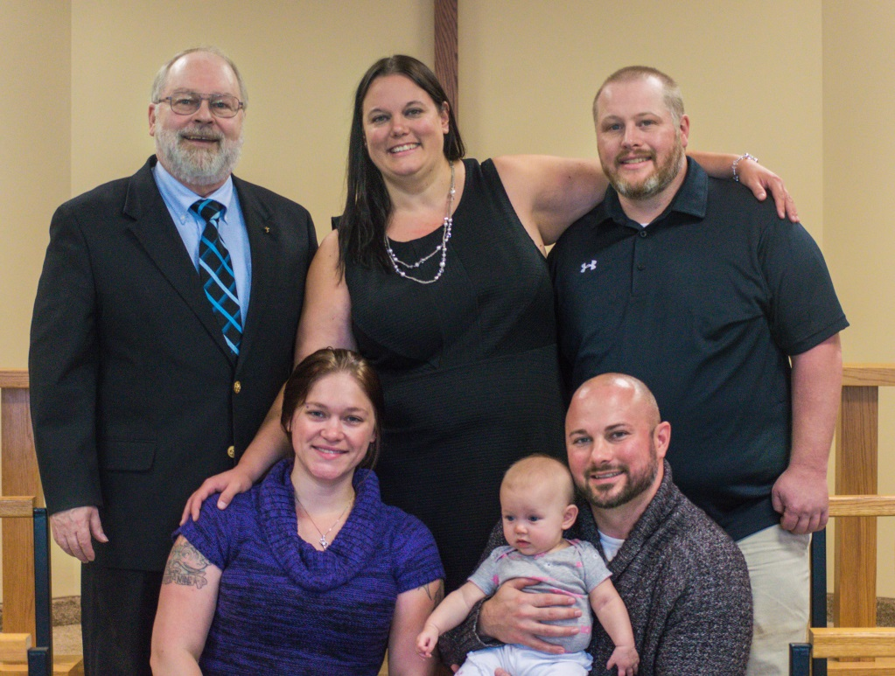

Evelyn Christina Knutson was baptized at New Hope Lutheran Church in Grantsburg, on September 10. Evelyn is the daughter of Benjamin and Danielle Knutson of Pine City. Her sponsors are Nicole and Jason Meyer; all of whom were in attendance, as were many family members and friends.

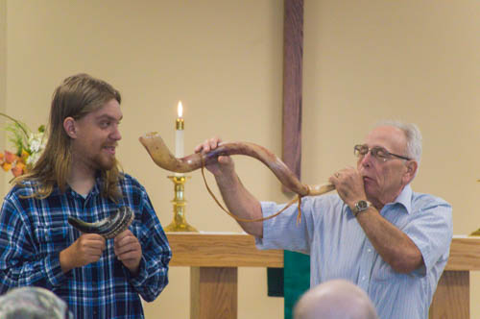
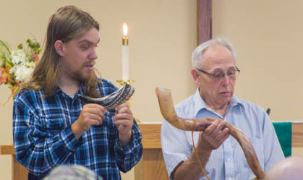
Thank You to Mark Loomis and Michael Corty for sounding the Shofar, the trumpet, in our Worship Service, during the Appointed Time of Trumpets.

October 2017
1 | 2 | 3 | 4 | 5 | 6 | 7
Worship Service:9:30 am  Followed by  coffee and fellowship  Confirmation: 10:45 am  Adult Bible Study :  11:15-11:45 am  Sunday School  11:00-Noon |  | Bible Study  7 pm | Men’s Bible Study:6:30 am  Quilting 9am  Prayer meeting:2 pm  Noah’s Park 3:30 (Calvary)  Bell Choir 6 pm  Adult Choir 7 pm
8 | 9 | 10 | 11 | 12 | 13 | 14
Worship Service:9:30 am  Followed by  coffee and fellowship  Confirmation: 10:45 am  Adult Bible Study :  11:15-11:45 am  Sunday School  11:00-Noon |  | Bible Study  7 pm | Men’s Bible Study:6:30 am  Quilting 9am  Prayer meeting:2 pm  Noah’s Park 3:30 (Calvary)  Bell Choir 6 pm  Adult Choir 7 pm | Council Meetings beginning  at 6:30 pm | Church Secretary office will not open until 1pm this day. | Coats for Kids  8am-11am  At  Siren Assembly of God  Spaghetti Dinner Fundraiser  5-8 pm at  Calvary Covenant
15 | 16 | 17 | 18 | 19 | 20 | 21
Worship Service:9:30 am  Followed by  coffee and fellowship  Adult Bible Study :  11:15-11:45 am  Sunday School  11:00-Noon  All Church Hayride  3 pm |  | Bible Study  7pm  Church Secretary office Closed | Men’s Bible Study:6:30 am  Quilting 9am  Prayer meeting:2 pm  Noah’s Park 3:30 (Calvary)  Bell Choir 6 pm  Adult Choir 7 pm  Church Secretary office Closed | The church Secretary office will be open from 9-3:30 this day | Church Secretary office will have split hours this day 10am-11am and then 3 pm- 6pm.
22 | 23 | 24 | 25 | 26 | 27 | 28
Worship Service:9:30 am  Followed by  coffee and fellowship  Confirmation: 10:45 am  Adult Bible Study :  11:15-11:45 am  Sunday School  11:00-Noon |  | Bible Study  7 pm  Church Secretary office will not open until noon this day. | Men’s Bible Study:6:30 am  Quilting 9am  Prayer meeting:2 pm  Noah’s Park 3:30 (Calvary)  Bell Choir 6 pm  Adult Choir 7 pm
29 | 30 | 31
Worship Service:9:30 am  Followed by  coffee and fellowship  Adult Bible Study :  11:15-11:45 am  Sunday School  11:00-Noon |  | No Bible Study

NEW HOPE LUTHERAN CHURCH
685 W. State Rd. 70
P. O. Box 7 Grantsburg, WI 54840 Dr. Emory L. Johnson, Pastor
Kobi Phillipps, Intern Pastor
Casey Corty, Secretary
Dr Ken Hyatt, Men’s Bible Study
Church Office: 715-463-5700
Fax: 715-463-5770
Secretary Email: info@newhopelutheranchurch.org
Website: newhopelutheranchurch.org
https://www.facebook.com/grantsburgnewhopelutheranchurch/

NEW HOPE LUTHERAN CHURCH UPDATE
October 2017

To the New Hope Lutheran Congregation:

- Thank You~ A big thank you to our council and to all who helped set up, prepare, serve and donated food items for the annual Pancake Breakfast on September 10.

- Thank You~ Thank you to all the volunteers that helped at New Hope’s booth September 16 at GrantOberfest! From the planning and preparation to the take down of our booth, serving the ice-cream, and overseeing the game, this ministry of outreach would only be possible with the time and energy given by everyone involved. Thank you to those who donated goods or funds for the event and thank you to Dairy Queen in St Croix falls for donating the soft serve ice cream machine. It was truly a success and we are grateful for our New Hope Family.

- Coats for Kids~ A tote for “Coats for Kids” has been place by the coat rack in the front entryway to our church. Several have expressed interest in donating coats to this cause and it is very much appreciated. The tote will be picked up on Sunday October 8. The 10th annual “Coats for Kids’ distribution day will be at the Siren Assembly of God Church on Saturday, October 14th from 8 am until 11 am. Everyone is welcome. Sylvia Hansen and Committee

- Grantsburg Life Chain: October 1 ~The National Life Chain took place on October 1, in support of the sanctity of human life from the moment of conception until natural death. Participants formed a chain of people along the road holding signs, meditating, and praying as the traffic passed by. These signs included: "Abortion Hurts Women", "Jesus Forgives and Heals", "Adoption: the Loving Option"', "Lord Forgive Us and Our Nation", etc. The community was invited to join the Life Chain by meeting at Grace Baptist Church 10 minutes prior to the rally. Coffee, hot cocoa, apple cider and desserts were served. The Life Chain extended to Immaculate Conception Catholic Church and lasted from 2:00 to 3:30 pm.
For more information contact
David Vollendorf, Grantsburg Life Chain Coordinator,
(715) 472-2992 or email: dvvollendorf@hotmailmail.com
You can also obtain additional information at: www.nationallifechain.org.

- Quilting~ Quilting meets weekly. Come join us on Wednesdays at 9 am for fellowship and quilting. Everyone is welcome--sewing is NOT required to help! If you can sew a machine is available for use to sew around the edges of the quilts or for ladies who would like to make tops. The quilters are in need of donations of sheets to use as backs for the beautiful quilts they make. You may bring in donations on Sundays or drop them off with the church office during the week. Any sheets of any size are welcome.

- Spaghetti Dinner Fundraiser~ Please join Calvary Covenant for a spaghetti dinner, freewill offering, on Saturday, October 14, 5-8pm. This is a teen youth group fundraiser to help send the youth group to a conference in Tennessee in July.

- The All-Church Hayride - Sunday, October 15 ~, New Hope, Noah’s Park and Youth Group families are all invited! The hayride begins at 3:30 p.m. at the farm of Doug and Nina Dewing 24376 N Fossum Road, Grantsburg. The hayride will be followed by a potluck dinner, bring a dish to pass. Hot dogs and drinks will be provided.

- Junior Choir Needs Voices~ The New Hope Jr Choir will practice on Sundays at 11 am in the sanctuary. All children ages 3 to 6th grade are welcome!!

- Senior Choir Needs Voices - Reading Music Not Required The New Hope Senior Choir practices on Wednesday, at 7pm at the church. Please consider joining this inspirational group! There are no voice tryouts. Our motto is: You do your best and God will do the rest!

- Bell Ringers needed - No experience or Music Reading Required For the first time New Hope has begun a Bell Choir on Wednesdays at 6pm. This choir is open for 3rd grade through adult.

- Life’s Healing Choices~ “Life’s Healing Choices” by John Baker founder of “Celebrate Recovery” will be started. This small group takes a deeper look at the hurts, habits, and hang-ups that stifle the abundant life God has planned for us. We learn how to release past hurts, apply God’s truths to everyday decision-making, forgive and ask others for forgiveness, and build a healthy foundation for change. This group is led by Roselyn Peters and meets at the Grantsburg Public Library on Tuesdays from 10 am to 12 pm and will run for 10 weeks through November 7th. If you are interested in this group please see Roselyn or call the church office.

- Noah’s Park~ New Hope Lutheran and Calvary Covenant have joined together for the after school program for children 3 years old through 6th grade. The Wednesday program is held at Calvary Covenant Church in Alpha. The Grantsburg bus routes that pass Calvary Covenant are presently full so Calvary will be sending drivers to pick up those children who need rides from the school to Calvary. Please contact the church office and the school to let them know if your children will be riding with them. Please pick up a permission slip for your child to attend the Noah's Park after School Program and return it to our church office. There will be opportunities for the children to sing at both New Hope and Calvary on selected Sunday mornings. The program will follow the school calendar. If there is no school, school is cancelled, there is early release or early dismissal, there will be no Children's Program at Calvary that afternoon. The time to pick up your children at Calvary will be at 5:15 p.m. on Wednesdays.

- New Member Recognition~
We will recognize new members during a worship service in October. New Hope is still receiving new members. If you are interested in becoming a member please contact the church office

- Coffee Hour/ Bulletin folding: We are looking for volunteers on Fridays at 1 pm. Please join us for some fellowship time with coffee and a light snack while we fold the bulletins for the Sunday Service.

- Prayer Shawls ~ If you know someone who could use a prayer shawl, please contact Sylvia Hanson. Those of you who are making prayer shawls can put them in the totes in the storage room. God bless all of you for making these prayer shawls. They give much hope and love to each receiver.

- Baby Grand Piano Fundraiser~ We are looking to purchase a baby grand piano for our sanctuary which will cost in the neighborhood of $8,800. Breaking that amount down comes to $100 for each one of the 88 piano keys. There is a piano fund keyboard poster placed in the fellowship hall. For every gift given a portion of one of the 88 piano keys will be colored in as we head toward that goal. If you wish to donate an entire key in memory of someone please let Casey know. To make a gift toward this fundraiser, in addition to your regular offering, please put the amount and the word, "Piano Fund" on the "Other" section of your offering envelope or in the memo line of your check. $2,900 has already been given so far Thank You

- Tuesday Bible Studies~ This Study group is meeting on Tuesdays at 7 pm (in the Sunday School room).

- Men’s Bible Study- Book of Luke~ An interesting study, filled with action and adventure so relevant to finding peace and direction in our turbulent times, led by Dr. Ken Hyatt, is being presented on the book of Luke. This study is offered Wednesday mornings at 6:30 am at the coffee shop, “Harper’s Hangout”

- Bible Study- Not a Fan~ New Bible Study series starting on Sunday, October 8th at 7pm at Tammy and Gene Bloomberg's titled Not a Fan.
Jesus is NOT looking for fans…He’s looking for followers.
Followers who understand that…
There is no forgiveness without repentance.
There is no salvation without surrender.
There is no life without death.
There is no believing without following.
Twenty times in the New Testament, Jesus Christ issued a compelling and challenging invitation: “Follow Me.”
Jesus is not interested in mere fans. He doesn't want enthusiastic admirers. He wants completely committed followers.
This is not a conventional small group experience. It is a cinematic journey, a series of six mini-movies,with the perspective and depth to help shape today’s believer into a first century Christ-follower.
Please plan to join us for this exciting and informative journey!

- Council: The next Council meeting is Thursday, October 12 at 7:30pm. Anyone is welcome to attend or bring issues to a Council member to be addressed.

Our church family is filled with many talented and generous people! I’d like to thank everyone for volunteering their time and expertise in various areas, both large and small. We have had an exciting year and are growing. The Ministry accomplished here could not be done without the generosity of everyone involved. God has truly blessed us at New Hope.

Casey Corty
NHLC Secretary

Thy word is a lamp unto my feet and a light unto my path.
Psalm 119:105

