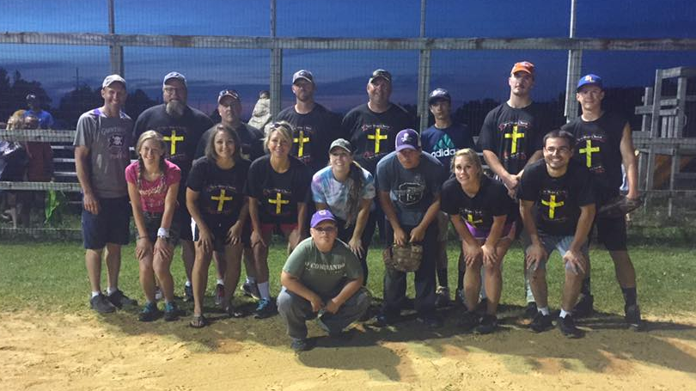
2017 Church Softball Championship Runners up –
Pictured below are players from New Hope Lutheran and Living Hope Church
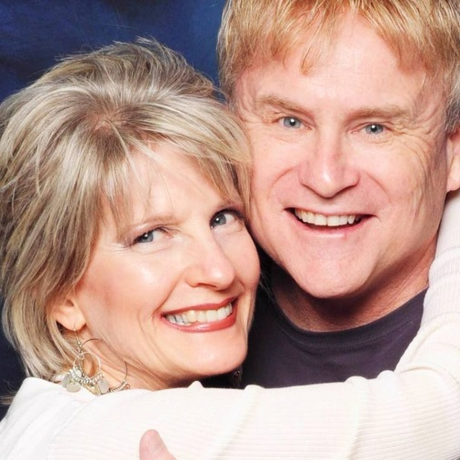
Thank you to Terry and Barbi Franklin of Love Sings Ministries
for their ministry in Word and Song for us on August 20.

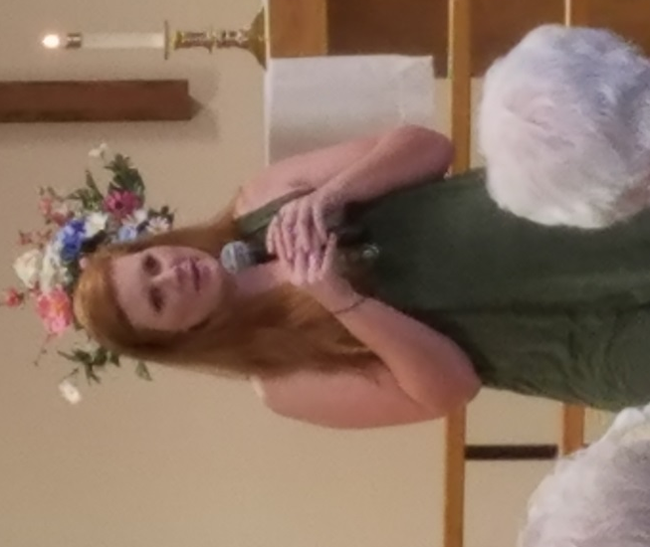
Thank you to Jillian Schinzing for her ministry with us on August 27. Our mission offerings helped to provide Jillian with some of the funds that she needed for her mission ministry this past year

September 2017
 |  |  |  |  | 1 | 2
3 | 4 | 5 | 6 | 7 | 8 | 9
Worship Service:9:30 am  Blessing of the Backpacks during Service  Followed by  coffee and fellowship  Adult Bible Study :  11:15-11:45 am | DivorceCare  6-8 pm |  | Men’s Bible Study:6:30 am  Quilting 9am  Prayer meeting: 2 pm | Council Meetings beginning  at 6:30 pm
10 | 11 | 12 | 13 | 14 | 15 | 16
Worship Service:9:30 am  Followed by  Pancake Breakfast  Adult Bible Study :  11:15-11:45 am | DivorceCare  6-8 pm |  | Men’s Bible Study:6:30 am  Quilting 9am  Prayer meeting:2 pm  Noah’s Park 3:30 (Calvary) |  |  | Grantoberfest  Grantsburg Fair Grounds  10am - 4pm
17 | 18 | 19 | 20 | 21 | 22 | 23
Worship Service:9:30 am  Followed by  coffee and fellowship  Adult Bible Study :  11:15-11:45 am | DivorceCare  6-8 pm |  | Men’s Bible Study:6:30 am  Quilting 9am  Prayer meeting: 2 pm  Noah’s Park 3:30 (Calvary)
24 | 25 | 26 | 27 | 28 | 29 |  | 30
Worship Service:9:30 am  Followed by  coffee and fellowship  Adult Bible Study :  11:15-11:45 am | DivorceCare  6-8 pm |  | Men’s Bible Study:6:30 am  Quilting 9am  Prayer meeting: 2 pm  Noah’s Park 3:30 (Calvary)

NEW HOPE LUTHERAN CHURCH
685 W. State Rd. 70
P. O. Box 7 Grantsburg, WI 54840 Dr. Emory L. Johnson, Pastor
Kobi Phillipps, Intern Pastor
Casey Corty, Secretary
Dr Ken Hyatt, Men’s Bible Study
Church Office: 715-463-5700
Fax: 715-463-5770
Secretary Email: info@newhopelutheranchurch.org
Website: newhopelutheranchurch.org
https://www.facebook.com/grantsburgnewhopelutheranchurch/

NEW HOPE LUTHERAN CHURCH UPDATE
September 2017

To the New Hope Lutheran Congregation:

- Thank You~ Thank you to everyone who baked cakes, helped serve, and came out to help the residents of the CCC and Shady Knoll homes celebrate their birthdays on August 16th.

- Quilting~ Quilting meets weekly. Come join us on Wednesdays at 9 am for fellowship and quilting. Everyone is welcome--sewing is NOT required to help! If you can sew a machine is available for use to sew around the edges of the quilts or for ladies who would like to make tops.The quilters are in need of donations of sheets to use as backs for the beautiful quilts they make. You may bring in donations on Sundays or drop them off with the church office during the week. Any sheets of any size are welcome.

- Survey~ A Survey of Possible Future Church Building Sites for New Hope Lutheran Church has been sent out as an email. We would like everyone to please fill out the survey and return it to the church office. You may print and fill it out or simply fill it out as a return email. There are a few printed copies available on the back table for those who did not receive the email or were unable to fill it out through the email.

- Blessing of the Backpacks~ Sunday, September 3rd there will be a special blessing of all school children during worship service! Children should bring their backpacks to worship. Children will be invited to come forward with their backpacks for a moment of prayer and blessing.

- Pancake Breakfast ~ Sunday, September 10, the New Hope Lutheran Church Council will be holding the 5th Annual Pancake Breakfast with maple syrup and all the fixings for the congregation and visitors following our service.

- Life’s Healing Choices~ “Life’s Healing Choices” by John Baker founder of “Celebrate Recovery” will be starting this week. This small group takes a deeper look at the hurts, habits, and hang-ups that stifle the abundant life God has planned for us. We learn how to release past hurts, apply God’s truths to everyday decision-making, forgive and ask others for forgiveness, and build a healthy foundation for change. This group is being put together by Rosalyn Peters and will begin meeting at the Grantsburg Public Library on September 5th at 10 am to 12 pm and will run for 10 weeks. If you are interested in this group please see Rosalyn or call the church office.
- Grantoberfest - September 16 - Volunteers Needed ~New Hope will be hosting a booth at Grantoberfest from 10 A.M. to 4 P.M. Saturday, September 16. We will be giving out free ice-cream cones again this year; we are also blessed to have use of a soft serve machine from Dairy Queen. We are looking for volunteers who are willing and able to help serve at the booth and with the games. We are also looking for volunteers to help with set up and tear down of our booth. We will need someone to help take our tables and supplies up to the fairgrounds on Friday September 15 at 5 pm. We are also in need of someone who can climb a ladder to hang our banner. A sign-up sheet is on the back table of the sanctuary with hourly time slots.

- Noah’s Park Registration~ Information letters and registration forms are being mailed out. You may turn these forms in to Casey, to Calvary Covenant, or send them with your children on the first day. Noah’s Park will begin Wednesday, September 13 at 3:30 at Calvary Covenant Church in Alpha. Informational letters and registration forms are on the back table in the sanctuary for those who do not receive one through the mail.

- New Member Recognition~
We will recognize new members during a worship service in October. New Hope is still receiving new members. If you are interested in becoming a member please contact the church office

- Coffee Hour/ Bulletin folding: We are looking for volunteers on Fridays at 1 pm. Please join us for some fellowship time with coffee and a light snack while we fold the bulletins for the Sunday Service.

- Baby Grand Piano Fundraiser~ We are looking to purchase a baby grand piano for our sanctuary which will cost in the neighborhood of $8,800. Breaking that amount down comes to $100 for each one of the 88 piano keys. There is a piano fund keyboard poster placed in the fellowship hall. For every gift given a portion of one of the 88 piano keys will be colored in as we head toward that goal. If you wish to donate an entire key in memory of someone please let Casey know. To make a gift toward this fundraiser, in addition to your regular offering, please put the amount and the word, "Piano Fund" on the "Other" section of your offering envelope or in the memo line of your check. $2,300 has already been given so far Thank You
- Prayer Shawls ~ If you know someone who could use a prayer shawl, please contact Sylvia Hanson. Those of you who are making prayer shawls can put them in the totes in the storage room. God bless all of you for making these prayer shawls. They give much hope and love to each receiver.

- DivorceCare~
This 14 week series is held Mondays from 6:00 to 8:00 pm. DivorceCare is a weekly video seminar series and support group for people who are separated or divorced. This 14-week program is produced by top experts in grief and recovery. Videos are combined with support group discussions of the materials presented each evening and cover the topics of facing anger, depression and loneliness, new relationships, financial survival, forgiveness, reconciliation and moving on. The small groups are led by those who have experienced and moved through this difficult life experience and seek to help restore hope through this Christ-centered ministry. If you are interested in attending the sessions or would like more information please call Kobi Phillipps at (715) 431-0187 or email the church office:info@newhopelutheranchurch.org. Walk-ins are welcome

- Tuesday Bible Studies~ This Study group is meeting on Tuesdays at 7 pm (in the Sunday School room).

- Men’s Bible Study- Book of Hebrews~ An interesting study, filled with action and adventure so relevant to finding peace and direction in our turbulent times, led by Dr. Ken Hyatt, is being presented on the book of Hebrews. This study is offered Wednesday mornings at 6:30 am at the coffee shop, “Harper’s Hangout”

- Bible Study Galatians Please join us for an in depth study of the book of Galatians. Paul's letter to the Galatians was addressed to a group of churches in Galatia a region of modern day Turkey. Have you ever wondered: Why is Galatians so important? Why does Paul seem so angry with these churches? What is the big idea of this book? How do I apply this in my life? Please join us as we study to find answers to these questions and more. This study meets at Tammy and Gene Blomberg's home, 13350 North Rd., Grantsburg, on the second and fourth Sunday's at 7:00 pm

- Council: The next Council meeting is Thursday, September 7 at 7:30pm. Anyone is welcome to attend or bring issues to a Council member to be addressed.

Our church family is filled with many talented and generous people! I’d like to thank everyone for volunteering their time and expertise in various areas, both large and small. We have had an exciting year and are growing. The Ministry accomplished here could not be done without the generosity of everyone involved. God has truly blessed us at New Hope.

Casey Corty
NHLC Secretary

Thy word is a lamp unto my feet and a light unto my path.
Psalm 119:105

