Happenings At New Hope

Janaury 8 we were blessed to have Eunice Tollander’s Family attend Worship Service and fellowship time to celebrate Eunice’s 90th Birthday.
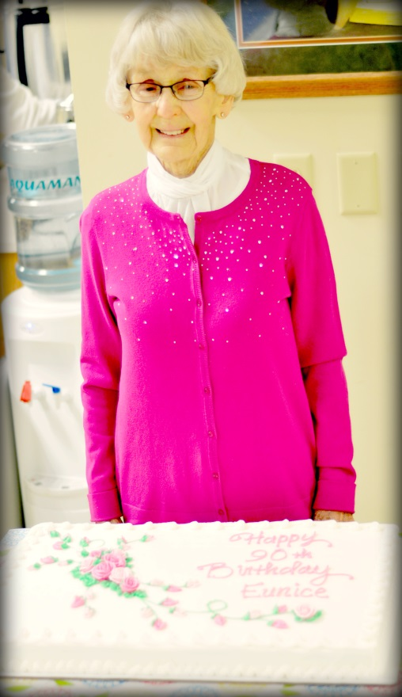

Thank You Note From Eunice: A very special Thank You for all the many beautiful cards and personal greetings given to me for my 90th birthday. I would also like to thank Pastor as he always does such Special things to honor all of us. I was happy to have my family with me and enjoyed my five Great Grandchildren, Reid, my youngest grandson said “Oh, that’s cool”, when Pastor announced that he was going to show “The Drummer Boy” on the screen. I was happy the younger ones went up for the Children’s sermon.
God Bless You all,
Eunice Tollander

February 2017
29 | 30 | 31 | 1 | 2 | 3 | 4
 |  | Biblical Covenants  Bible Study  7 pm | Men’s Bible Study:  6:30 am  Biblical Covenants  Bible Study: 12 pm  Quilting 9am  Prayer meeting: 2 pm  Noah’s Park 3:30 (Calvary)  Choir:7:00 pm
5 | 6 | 7 | 8 | 9 | 10 | 11
Annual Meeting  Fellowship hall following Service | DivorceCare  6-8 pm | Biblical Covenants  Bible Study  7 pm | Men’s Bible Study:  6:30 am  Biblical Covenants  Bible Study: 12 pm  Quilting 9am  Prayer meeting: 2 pm  Noah’s Park 3:30 (Calvary)  Choir:7:00 pm | Board of Worship Meeting:  6:30 pm  Board of Trustees Meeting:  6:30 pm  Full Council Meeting:  7:30 pm
12 | 13 | 14 | 15 | 16 | 17 | 18
 | DivorceCare  6-8 pm | Biblical Covenants  Bible Study  7 pm | Men’s Bible Study:  6:30 am  Biblical Covenants  Bible Study: 12 pm  Quilting 9am  Prayer meeting: 2 pm  Noah’s Park 3:30 (Calvary)  Choir:7:00 pm |  |  | “The Marriage You’ve Always Wanted”  Marriage Enrichment class  6:30-8 pm
19 | 20 | 21 | 22 | 23 | 24 | 25
 | DivorceCare  6-8 pm | Biblical Covenants  Bible Study  7 pm | Men’s Bible Study:  6:30 am  Biblical Covenants  Bible Study: 12 pm  Quilting 9am  Prayer meeting: 2 pm  Noah’s Park 3:30 (Calvary)  Choir:7:00 pm |  |  | “The Marriage You’ve Always Wanted”  Marriage Enrichment class  6:30-8 pm
26 | 27 | 28 | 1 | 2 | 3 | 4
 | DivorceCare  6-8 pm | Biblical Covenants  Bible Study  7 pm | Men’s Bible Study:  6:30 am  Biblical Covenants  Bible Study: 12 pm  Quilting 9am  Prayer meeting: 2 pm  Noah’s Park 3:30 (Calvary)  Choir:7:00 pm |  |  | “The Marriage You’ve Always Wanted”  Marriage Enrichment class  6:30-8 pm
5 | 6 | 7 | 8 | 9 | 10 | 11
 | DivorceCare  6-8 pm | Biblical Covenants  Bible Study  7 pm | Men’s Bible Study:  6:30 am  Biblical Covenants  Bible Study: 12 pm  Quilting 9am  Prayer meeting: 2 pm  Noah’s Park 3:30 (Calvary)  Choir:7:00 pm |  |  | “The Marriage You’ve Always Wanted”  Marriage Enrichment class  6:30-8 pm

NEW HOPE LUTHERAN CHURCH
685 W. State Rd. 70
P. O. Box 7 Grantsburg, WI 54840 Dr. Emory L. Johnson, Pastor
Church Office: 715-463-5700
Fax: 715-463-5770
Secretary Email: info@newhopelutheranchurch.org
Website: newhopelutheranchurch.org
https://www.facebook.com/grantsburgnewhopelutheranchurch/

NEW HOPE LUTHERAN CHURCH UPDATE
February 2017

To the New Hope Lutheran Congregation:

NOTICE OF ANNUAL MEETING
- PLEASE TAKE NOTICE, MEMBERS OF NEW HOPE LUTHERAN CHURCH: The Annual Meeting of New Hope Lutheran Church will take place on Sunday, February 5, 2016, immediately following the worship service.

- Church Website Update If you are unsure of a time of any of the upcoming events, here at New Hope, you can find the event information on the church website: http://newhopelutheranchurch.org/calendar/. If you would like to hear an audio of just the sermon from each Sunday, they have been restored to the homepage of the church website. The weekly bulletins can be downloaded as a Microsoft word document as well.

- DivorceCare is coming to Grantsburg. This 13 week series will begin Mondays starting Feb 6 from 6:00 to 8:00 pm. DivorceCare is a weekly video seminar series and support group for people who are separated or divorced. This 13-week program is produced by top experts in grief and recovery. Videos are combined with support group discussions of the materials presented each evening and covers the topics of facing anger, depression and loneliness; new relationships; financial survival; forgiveness; reconciliation; and moving on. The small groups are led by those who have experienced and moved through this difficult life experience and are able to help restore hope in this Christ-centered ministry. If you are interested in attending the sessions or would like more information please call (715)463-5700 or email the church office: info@newhopelutheranchurch.org. Pre-registration is appreciated but walk-ins are welcome.

- The Marriage You've Always Wanted - Want to experience a life-changing marriage conference, but don't have the time or money for a weekend away? Spend five Saturday evenings at New Hope Lutheran Church, for a series of videos led by Dr. Gary Chapman, author of the #1 New York Times bestseller The 5 Love Languages® This 5 week event is designed to help engaged and married couples build the love relationship of their dreams. The five week sessions include Communication, Expressing Love, Initiating Change, Sex, and Things that Bug you. Learn how to share yourself fully with your spouse and express love in a meaningful way. This study will be coming to our church on Saturdays, beginning February 18, 6:30-8:00 p.m. and run for 5 weeks. This study will be facilitated by Kobi and Vickie Phillipps. The optional workbook is $10 and includes daily devotionals and materials that supplement the videos. Information sheets are on the table in the back of the sanctuary. More information will be attached to the newletter.

- Noah’s Park Snacks~Thank you so much for the wonderful snacks for the children! We hear comments on how much they are enjoyed. We have a need for some more fresh string cheese for the children. We provide this on a weekly basis in addition to the yummy snacks

- Grantsburg Food Shelf~ The Grantsburg Area Food Shelf Board is in need of two representatives from New Hope to serve a three year term. For more information please contact the church office.

- Tuesday/Wednesday Bible Studies~ Melissa McIntyre is leading a Bible Study on Biblical Covenants on Tuesdays at 7 pm (Sunday School room) and repeated at Noon on Wednesdays. In this series, we will gain a better understanding of the idea of Covenant and consider six Old Testament Covenants through which God has worked in human history. Hopefully, we will also gain an even greater appreciation of the life-transforming differences between, especially, the Mosaic Covenant and the New Covenant established in Christ Jesus.

- Quilting is starting again. Come join us on Wednesdays, at 9 am for fellowship and quilting. Everyone is welcome--sewing is NOT required to help!

- At each of our Sunday services there are opportunities to help assist in our time of worship. If you are willing and able to volunteer for any of the ministries needed please check out the sign-up sheet on the bulletin board in the fellowship hall. We have various areas in which we need help from the congregation. Also, if there is a time you would like to bring altar flowers in honor or memory of someone, or just because, there is a sign-up sheet for that too. Thank you to all who volunteer their time and talent at New Hope!
.
- Men’s Bible Study- Book of Acts~ An interesting study, filled with action and adventure so relevant to finding peace and direction in our turbulent times is being led by Dr. Ken Hyatt, on the Book of Acts. This study is offered Wednesday mornings at 6:30 am at the “Grantsburg Mo Joe” formerly known as the Wake-Up Call Coffee House.

- Bible Study Psalm 91 Do thoughts on terrorist attacks and epidemic outbreaks cause your heart to skip a beat? What about all the natural disasters that are striking in unexpected places? Do you sometimes wonder if there is any safe place in the world to hide? If any of these things has ever troubled your mind, please join us for an in-depth study of Peggy Joyce Ruth's Bible Study titled "Psalm 91 God's Umbrella of Protection" This study meets at Tammy and Gene Blomberg's home 13350 North Rd., Grantsburg, on the second and fourth Sunday's at 7:00 pm

- Facebook` You can now find New Hope on Facebook. Please click on “Like” and “Share”.
https://www.facebook.com/grantsburgnewhopelutheranchurch/.

- The next Council meeting is Thursday, February 9 at 7:30pm. Anyone is welcome to attend or bring issues to a Council member to be addressed.

Our church family is filled with many talented and generous people! I’d like to thank everyone for volunteering their time and expertise in various areas, both large and small. We have had an exciting year and are growing. The Ministry accomplished here could not be done without the generosity of everyone involved. God has truly blessed us at New Hope.

Casey Corty
NHLC Secretary

Thy word is a lamp unto my feet and a light unto my path.
Psalm 119:105

“The Marriage You’ve Always Wanted”
by Dr. Gary Chapman
5 Week Video Series

Each lesson takes about 45–60 minutes and includes two video clips that together run for 10–15 minutes.

Cost: Free - $10 for Optional Workbook (containing five weeks of daily devotions.)

When: Saturday evenings 6:30 – 8:00
February 18, 25, Mar 4, 11, 18 (walk-ins welcome)

Where: New Hope Lutheran Church, 685 State Highway 70
Grantsburg, WI 54840 715-463-5700

"Marriages either get better or worse. They never stand still."
Gary Chapman

Want to experience a life-changing marriage conference, but don't have the time or money for a weekend away?

Spend 5 weeks in a small group experience at New Hope Lutheran Church, hosted by Kobi and Vickie Phillipps where we will watch videos led by Dr. Gary Chapman, author of the #1 New York Times bestsellerThe 5 Love Languages®.Using his trademark warmth and humor, and bringing more than four decades of experience as a marriage counselor, Dr. Chapman walks couples through the simple yet critical steps to achieving the marriage they've always wanted.

Learn how to:
- Overcome your communication issues
- Give and receive love in the most meaningful ways
- Initiate positive change—even in the most difficult areas
- Make sex more mutually enjoyable
- Bring up behavior that bothers you

Weekly Schedule

Week 1 - February 18: Communication 101
Healthy, honest communication is essential to establish and maintain a thriving marriage. Most couples admit they experience difficulty having meaningful conversations with their spouse. Some sadly say, “We don’t really talk at all.” Hear Dr. Gary Chapman’s memorable anecdotes and practical advice for couples on this important topic. Discover your own tendency to be a “babbling brook” or a “dead sea” and how to deal with the implications of these characteristics to enhance communication in your marriage.

Week 2 - February 25: Understanding and Expressing Love
What should couples do when those exciting feelings of love seem to be long gone? Dr. Chapman explains how to rekindle those emotions with some easy strategies that help husbands and wives express love to their spouses and refill each others empty “love tanks.” Learn your spouse’s “love language” and choose to act out of love—two crucial steps to renewing your relationship.

Week 3 – March 4: Initiating Positive Change
Dr. Chapman has a word to both wives and husbands in this session, as he demonstrates how the model of the Godhead is the key to thriving marriages. While stressing the value and significance of both partners, he will help couples gain clarity in their quest toward a unified, God-honoring marriage. You’ll receive advice on how to handle strong disagreements, power struggles and poor decisions.

Week 4 - March 11: Making Sex a Mutual Joy
We may giggle or avoid the subject, but there is no denying that God created sex and designed it as a powerful means for loving your spouse. Dr. Chapman reminds couples of God’s biblical intention for sex, while addressing common misconceptions and difficulties related to this important aspect of marriage.

Week 5 - March 18: How to Share the Things that Bug You
When differences within your marriage begin to give rise to resentment, how do you bring those issues up without damaging your mate? In this session, Dr. Chapman teaches ways to lovingly accept your spouse while letting your voice be heard. Learn the delicate art of constructive criticism and the value of a good laugh with your spouse.
These videos were recorded before a sold-out audience, and they will help couples take big steps toward the marriage they've always wanted.

