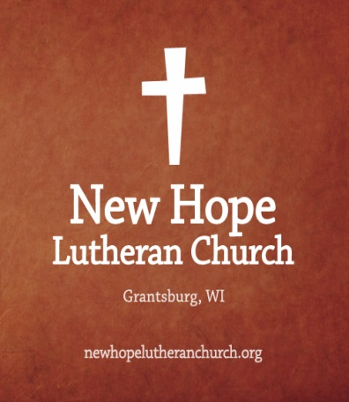
November Newsletter

[Happenings at New Hope]

685 W State Rd 7, Grantsburg, WI, 54840
newhopelutheranchurch.org https://www.facebook.com/grantsburgnewhopelutheranchurch/

Contact Us
Dr. Emory L. Johnson, Pastor
Kobi Phillipps, Assistant Pastor
Casey Corty, Secretary
Church Office: 715-463-5700 Fax: 715-463-5770
Secretary Email: info@newhopelutheranchurch.org

Important Church News

New Members~
New hope will be receiving New Members soon if you are interested in becoming a member please contact the church office.

Operation Christmas Child
Sara Moore will be setting up our Operation Christmas Child Store in the fellowship hall on November 1 at 9:30 am. Any and all help that can be given in setting up is appreciated.

Snow Shoveling Job
We are looking for someone to shovel snow this winter. This is a paid position and you must be available to shovel during the week as well as prior to Sunday morning worship service. Please see Casey if you are interested in this position

Noah’s Park~
New Hope Lutheran and Calvary Covenant have joined together again for the after school program for children 3 years old through 6th grade. The Wednesday program is held at Calvary Covenant Church in Alpha. The program will follow the school calendar. If there is no school, school is cancelled, there is early release or early dismissal, there will be no Children's Program at Calvary that afternoon. The time to pick up your children at Calvary will be at 5:15 p.m. on Wednesdays. Please Note on Wednesday, Nov. 7, Noah’s Park will meet at New Hope to pack the Christmas Shoe Boxes.
.

Upcoming Church Events
November 1
OCC Store Set Up 9:30 am

November 4
Congregational Meeting

November 7
Noah’s Park will be held at New Hope

Important Church Announcements

Sunday November 4, Daylight Savings Time ends. Be sure to turn your clocks back one hour. Remember in the Spring, spring ahead. In the Fall, fall back.

NOTICE OF CONGREGATIONAL MEETING~
We will be having a congregational meeting November 4 to approve the purchase of an outdoor storage building/container

Pastor Emory will be starting a six session Grief Support Group beginning the middle of November. If you are interested in attending please call the church office.

More Important Church News

Tuesday Night Bible Study~
A bible study led by Sara Moore will be held Tuesday nights at 7pm starting on November 6.

Men’s Bible Study-
This study meets at “The Country Store" On Wednesday mornings at 6:30 am. Ted Knutson is facilitating this study.

Congregational Prayer ~
Everyone in the congregation is invited to join us for a weekly congregational prayer time. The prayer meeting is here at the church on Wednesday afternoons from 2 to 3:00 p.m.

Special Thanksgiving and Christmas Offerings~
The council has voted that the special Thanksgiving offering will go toward postage for the Operation Christmas Child shoebox gifts that will be sent to children around the world. The special Christmas offering will go toward the Coats for Kids.

Church Secretary Office Hours~
Mondays- Closed
Tuesday, Thursday, Friday-10-4 pm
Wednesday - 9 am -3 pm or as needed

Council: The next Council meeting is Thursday, November 8 at 7:30pm. Anyone is welcome to attend or bring issues to a Council member to be addressed.

Get Connected in…

Church Nursery ~

Do you have children? We love the pleasure to minister to them while you’re in the service. They will have a lot of fun! Children may go to the nursery located in the Sunday School room.

Sunday School ~
11:00 -12:00 in the Sunday School rooms

Adult Bible Study~
11:15-11:45 in the Sanctuary

Confirmation Instruction ~
Nov. 11 and Nov.25
10:45am in Pastors Office

Tuesday Bible Study~
Tuesdays at 7 pm in the Sunday School room

Congregational prayer~
2-3 pm on Wednesdays in the Sunday School Rooms

November 2018
 |  |  |  | 1 | 2 | 3
Occ Store
Set up
9 sm
4 | 5 | 6 | 7 | 8 | 9 | 10
Daylight Saving Ends  Worship Service:9:30 am  Followed by  Congregation Meeting  coffee and fellowship  Adult Bible Study :  11:15-11:45 am  Sunday School  11:00-Noon |  | Tuesday  Bible Study  7 pm | Men’s Bible Study:6:30 am  Quilting 9am  Prayer meeting:2 pm  Noah’s Park 3:30  (New Hope)  Bell Choir 6:30 pm  Adult Choir 7:30 pm | Council Meetings beginning  at 6:30 pm
11 | 12 | 13 | 14 | 15 | 16 | 17
Worship Service:9:30 am  Followed by  coffee and fellowship  Confirmation Instruction  10:45am  Adult Bible Study :  11:15-11:45 am  Sunday School  11:00-Noon |  | Tuesday  Bible Study  7 pm | Men’s Bible Study:6:30 am  Quilting 9am  Prayer meeting:2 pm  Noah’s Park 3:30 (Calvary)  Bell Choir 6:30 pm  Adult Choir 7:30 pm |  | .
18 | 19 | 20 | 21 | 22 | 23 | 24
Worship Service:9:30 am  Followed by  coffee and fellowship  Adult Bible Study :  11:15-11:45 am  Sunday School  11:00-Noon |  | Tuesday  Bible Study  7 pm. | Men’s Bible Study:6:30 am  Quilting 9am  Prayer meeting:2 pm  Noah’s Park 3:30 (Calvary)  Bell Choir 6:30 pm  Adult Choir 7:30 pm | Happy Thanksgiving  Church offices are closed
25 | 26 | 27 | 28 | 29 | 30
Worship Service:9:30 am  Followed by  coffee and fellowship  Confirmation Instruction  10:45am  Adult Bible Study :  11:15-11:45 am  Sunday School  11:00-Noon |  | Tuesday  Bible Study  7 pm

