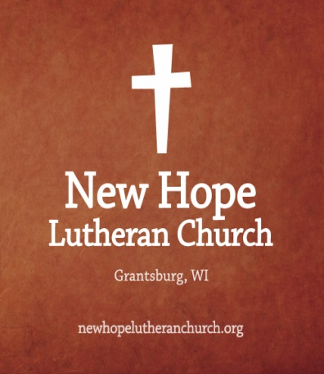
May Newsletter

[Happenings at New Hope]

685 W State Rd 70, Grantsburg, WI, 54840
newhopelutheranchurch.org https://www.facebook.com/grantsburgnewhopelutheranchurch/

Contact Us
Dr. Emory L. Johnson, Pastor
Casey Corty, Secretary
Church Office: 715-463-5700 Fax: 715-463-5770
Secretary Email: info@newhopelutheranchurch.org

Important Church News
All Junior and Senior High Youth May Event
We will be going to the 7:30 showing of Breakthrough at
the Siren Timber Theater on Tuesday, May 7. Please plan to meet at the church at 6:30 pm Tuesday May 7 to drive to the Theater in Siren for the movie. Please feel free to invite your friends. If you are planning to be dropped off at the theater, please contact Debi at the number below to let us know.

BREAKTHROUGH is based on the inspirational true story of one mother’s unfaltering love in the face of impossible odds. When Joyce Smith’s adopted son John falls through an icy Missouri lake, all hope seems lost. But as John lies lifeless, Joyce refuses to give up. Her steadfast belief inspires those around her to continue to pray for John’s recovery, even in the face of every case history and scientific prediction. Please contact Debi Smith at 612-232-4905 to reserve a ticket for this event.

Our Special Easter Offering-
Will go towards our Heaven Is For Real Community Ministry Event in August

Progressive Supper~
New Hope will be the Dessert stop at the Annual Progressive Dinner that will take place on May 11. Tickets are on sale now please see Casey to purchase yours. Cost for Adults is $15 Children 6-12 yrs is $7 and under 5 is free.

In Order to make this a success we are also in need of volunteers. We are in need of 4 more Bundt Cakes. We also need people to serve these cakes at the dinner. If you can fill any of these needs please see the sign up sheets on the back table of the sanctuary.

Upcoming Church Events
May 7
Youth Group Movie trip “Breakthrough”

May 11
Progressive Dinner

May 15
Grief Support Group

June 8
Women’s Event
(more information on page 4)

Aug. 3-4
Heaven is For Real Event
Important Church Announcements

Bible Camp Scholarship~
New Hope is offering scholarships to those youth who wish to attend a Bible Camp this summer. Just call the Church Office and let Casey know where and when you wish to go to camp.

On Sunday May 5, Allen McKinley, from The Gideons International will be
speaking during our worship service.

More Important Church News

Graduation Party~
The congregation is invited to a Graduation Party for Caleb Johnson on May 18 from 3 pm -6 pm. The party will be held at 14539 State Rd 70, in Grantsburg. Please RSVP to (612) 308-3010.

Noah’s Park Bars~
The last day of Noah’s Park will be May 8 followed by a dinner held after at Calvary Covenant. New Hope still needs to supply 4 more pans of bars. If you can help fill this need please see the signup sheet on the back table of the sanctuary.

VBS 2019 ~
Where: Calvary Covenant Church 11530 State Road 70. Grantsburg
When: June 24-28 from 1:30 to 5 PM
Who: Entering Little Pirates through 6th Grade
Sponsored by Calvary Covenant and New Hope Lutheran Church
To Register, fill out a registration form on the back table of the sanctuary and turn into the church office or Call: 715-689-2541 or 715-463-5700

We are in need of volunteers to help VBS run smoothly if you can help lead groups, help with crafts, leading games, etc. Please let the church office know what areas you are interested in helping with during the week of VBS.

Please Remember to Save These Dates: August 3 and 4
The Burpo family Colton (Boy who went to Heaven) Todd (Dad), and Sonja (Mom) are coming to Grantsburg High School on August 3 for two presentations and to New Hope
Lutheran church August 4 for morning Worship Service!

Bible Camp Scholarship~
New Hope is offering scholarships to those youth who wish to attend a Bible Camp this summer. Just call the Church Office and let Casey know where and when you wish to go to camp.

Grief Support Group~
Pastor Emory will be holding a 6 session Grief Support Group on Wednesdays May 15, 22, 29 and June 5,12,19 from 4-5 pm. If you are interested in attending the sessions please contact the church office at 715-463-5700..

Men’s Bible Study-
These studies meet at “The Country Store" at 6:30 am on Wednesday mornings to study “Nehemiah” and Friday mornings to study “Ecclesiastes”. Ted Knutson is facilitating the studies.

Get Connected…

SUNDAYS

Church Nursery ~
Do you have young children? We love the pleasure to minister to them while you’re in the service. They will have a lot of fun! Children may go to the nursery located in the Sunday School room.

Worship Service~
9:30 am followed by coffee and fellowship

Confirmation Instruction ~
Will be held
May 5, 19, 26
10:45 a.m. in Pastor’s Office
The Confirmation Service for our Confirmand will be June 2.

Sunday School ~
11:00 -12:00 in the Sunday School rooms

Adult Bible Study~
11:15-11:45 in the Sanctuary

Congregational prayer~
2-3 pm on Wednesdays in the Sunday School Room.

Youth Group~
Grades 7-12 meets monthy.

May 2019
 |  |  | 1 | 2 | 3 | 4
 |  |  | Men’s Bible Study:6:30 am at The Country Store  Quilting 9am  Prayer meeting:2 pm  Noah’s Park 3:30  (Calvary)  Bell Choi:6:30 pm  Choir: 7:30 pm |  | Men’s Bible Study:6:30 am at The Country Store
5 | 6 | 7 | 8 | 9 | 10 | 11
Worship Service:9:30 am  Followed by  coffee and fellowship  Confirmation Instruction  10:45am  Adult Bible Study :  11:15-11:45 am  Sunday School  11:00-Noon |  | Youth Group  “Break Through”  Movie trip. | Men’s Bible Study:6:30 am at The Country Store  Quilting 9am  Prayer meeting:2 pm  Noah’s Park 3:30  (Calvary)followed by Dinner  Bell Choi:6:30 pm  Choir: 7:30 pm | 6:30 pm  Full Council followed by  Board of Trustees and  Board of Worship | Men’s Bible Study:6:30 am at The Country Store | Progressive Supper
12 | 13 | 14 | 15 | 16 | 17 | 18
Mother’s Day  Worship Service:9:30 am  Followed by  coffee and fellowship  Adult Bible Study :  11:15-11:45 am  Sunday School  11:00-Noon |  |  | Men’s Bible Study:6:30 am at The Country Store  Quilting 9am  Prayer meeting:2 pm  Grief Support Group  4-5 pm  Bell Choi:6:30 pm  Choir: 7:30 pm |  | Men’s Bible Study:6:30 am at The Country Store
19 | 20 | 21 | 22 | 23 | 24 | 25
Graduation  Worship Service:9:30 am  Followed by  coffee and fellowship  Confirmation Instruction  10:45am  Adult Bible Study :  11:15-11:45 am  Sunday School  11:00-Noon |  |  | Men’s Bible Study:6:30 am at The Country Store  Quilting 9am  Prayer meeting:2 pm  Grief Support Group  4-5 pm |  | Men’s Bible Study:6:30 am at The Country Store
26 | 27 | 28 | 29 | 30
Worship Service:9:30 am  Followed by  coffee and fellowship  Confirmation Instruction  10:45am  Adult Bible Study :  11:15-11:45 am  Sunday School  11:00-Noon |  |  | Men’s Bible Study:6:30 am at The Country Store  Quilting 9am  Prayer meeting:2 pm  Grief Support Group  4-5 pm

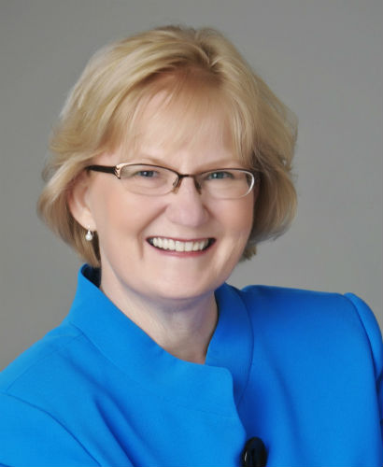
This is Livin’!

This is a FREE lady’s event
Open to all ladies
Saturday, June 8, 2019
10:00 am – 2:00 pm
New Hope Lutheran Church
Grantsburg, WI 54840
Please R.S.V.P. by calling
Debi Smith @ 715-463-3972
(as lunch is provided)

This is Livin’!

Good things happen to everybody. God is faithful, and grace and mercy are ours for the asking. And … messy moments happen, and life doesn’t always feel good! You will giggle and whisper, “Me too,” as Gaye shares stories and lessons learned from her own messiness and happy places. We’ll laugh and learn to celebrate great moments, which turn into great days, which turn into a great life. Let’s not wait until life is perfect to start enjoying it!

About Gaye Lindfors
Gaye loves to laugh and isn't afraid to poke fun at her own mishaps. From growing up in a small farming community to living in the big city, she loves the stories that came from observing life in the real world. She high-fives you when you do your happy dance, and whispers, "You are not alone" when the messiness comes. Gaye is the author of God, Girlfriends, & Chocolate, and This is Livin’! She served as the Midwest Regional Director for Christian Women in Media and is past-president of the National Speakers Association–MN Chapter.
All ladies are welcome!

